Mobility Fits

Weihsueh Chiu

6/20/2020

## Mobility data

Each mobility dataset for each state is Fit to Weibull+linear model, where the Weibull represents the process of sheltering in place, and linear represents the re-opening phase. The model is formulated as follows:

$$y=y_{s}\left\{θ_{min}+(1-θ_{min})⋅\left[s(t)+r(t)\right]\right\}$$

$$s(t)=exp\left[-(t/τ_{θ})^{n_{θ}}\right]$$

$$r(t)=r_{max}\frac{t-τ_{θ}-τ_{s}}{τ_{r}}\left[u(t-t_{r})-u(t-t_{rmax})\right]+u(t-t_{rmax})$$

$$u(t)=Heaviside(t)≈1-\frac{1}{1+e^{4t}}$$

$$t_{r}=τ_{θ}+τ_{s}$$

$$t_{rmax}=τ_{θ}+τ_{s}+τ_{r}$$

Here $y_{s}$ represents the baseline (pre-pandemic) value, and the Weibull term has parameters $θ_{min}$, $τ_{θ}$, and $n_{θ}$. The “reopening” term $r(t)$ is 0 prior to $t_{r}$, linear between $t_{r}$ and $t_{rmax}$, and constant at a value of $r_{max}$ after that, and made continuous by approximating the Heaviside function by a logistic function. The reopening time is defined as $τ_{s}$ days after $τ_{θ}$, and the maximum reopening amount $r_{max}$ happens $τ_{r}$ days after that. The time-dependence of both the sheltering phase $s(t)$ and reopening phase $r(t)$ are represented by functions with a range between 0 and 1.

### Unacast

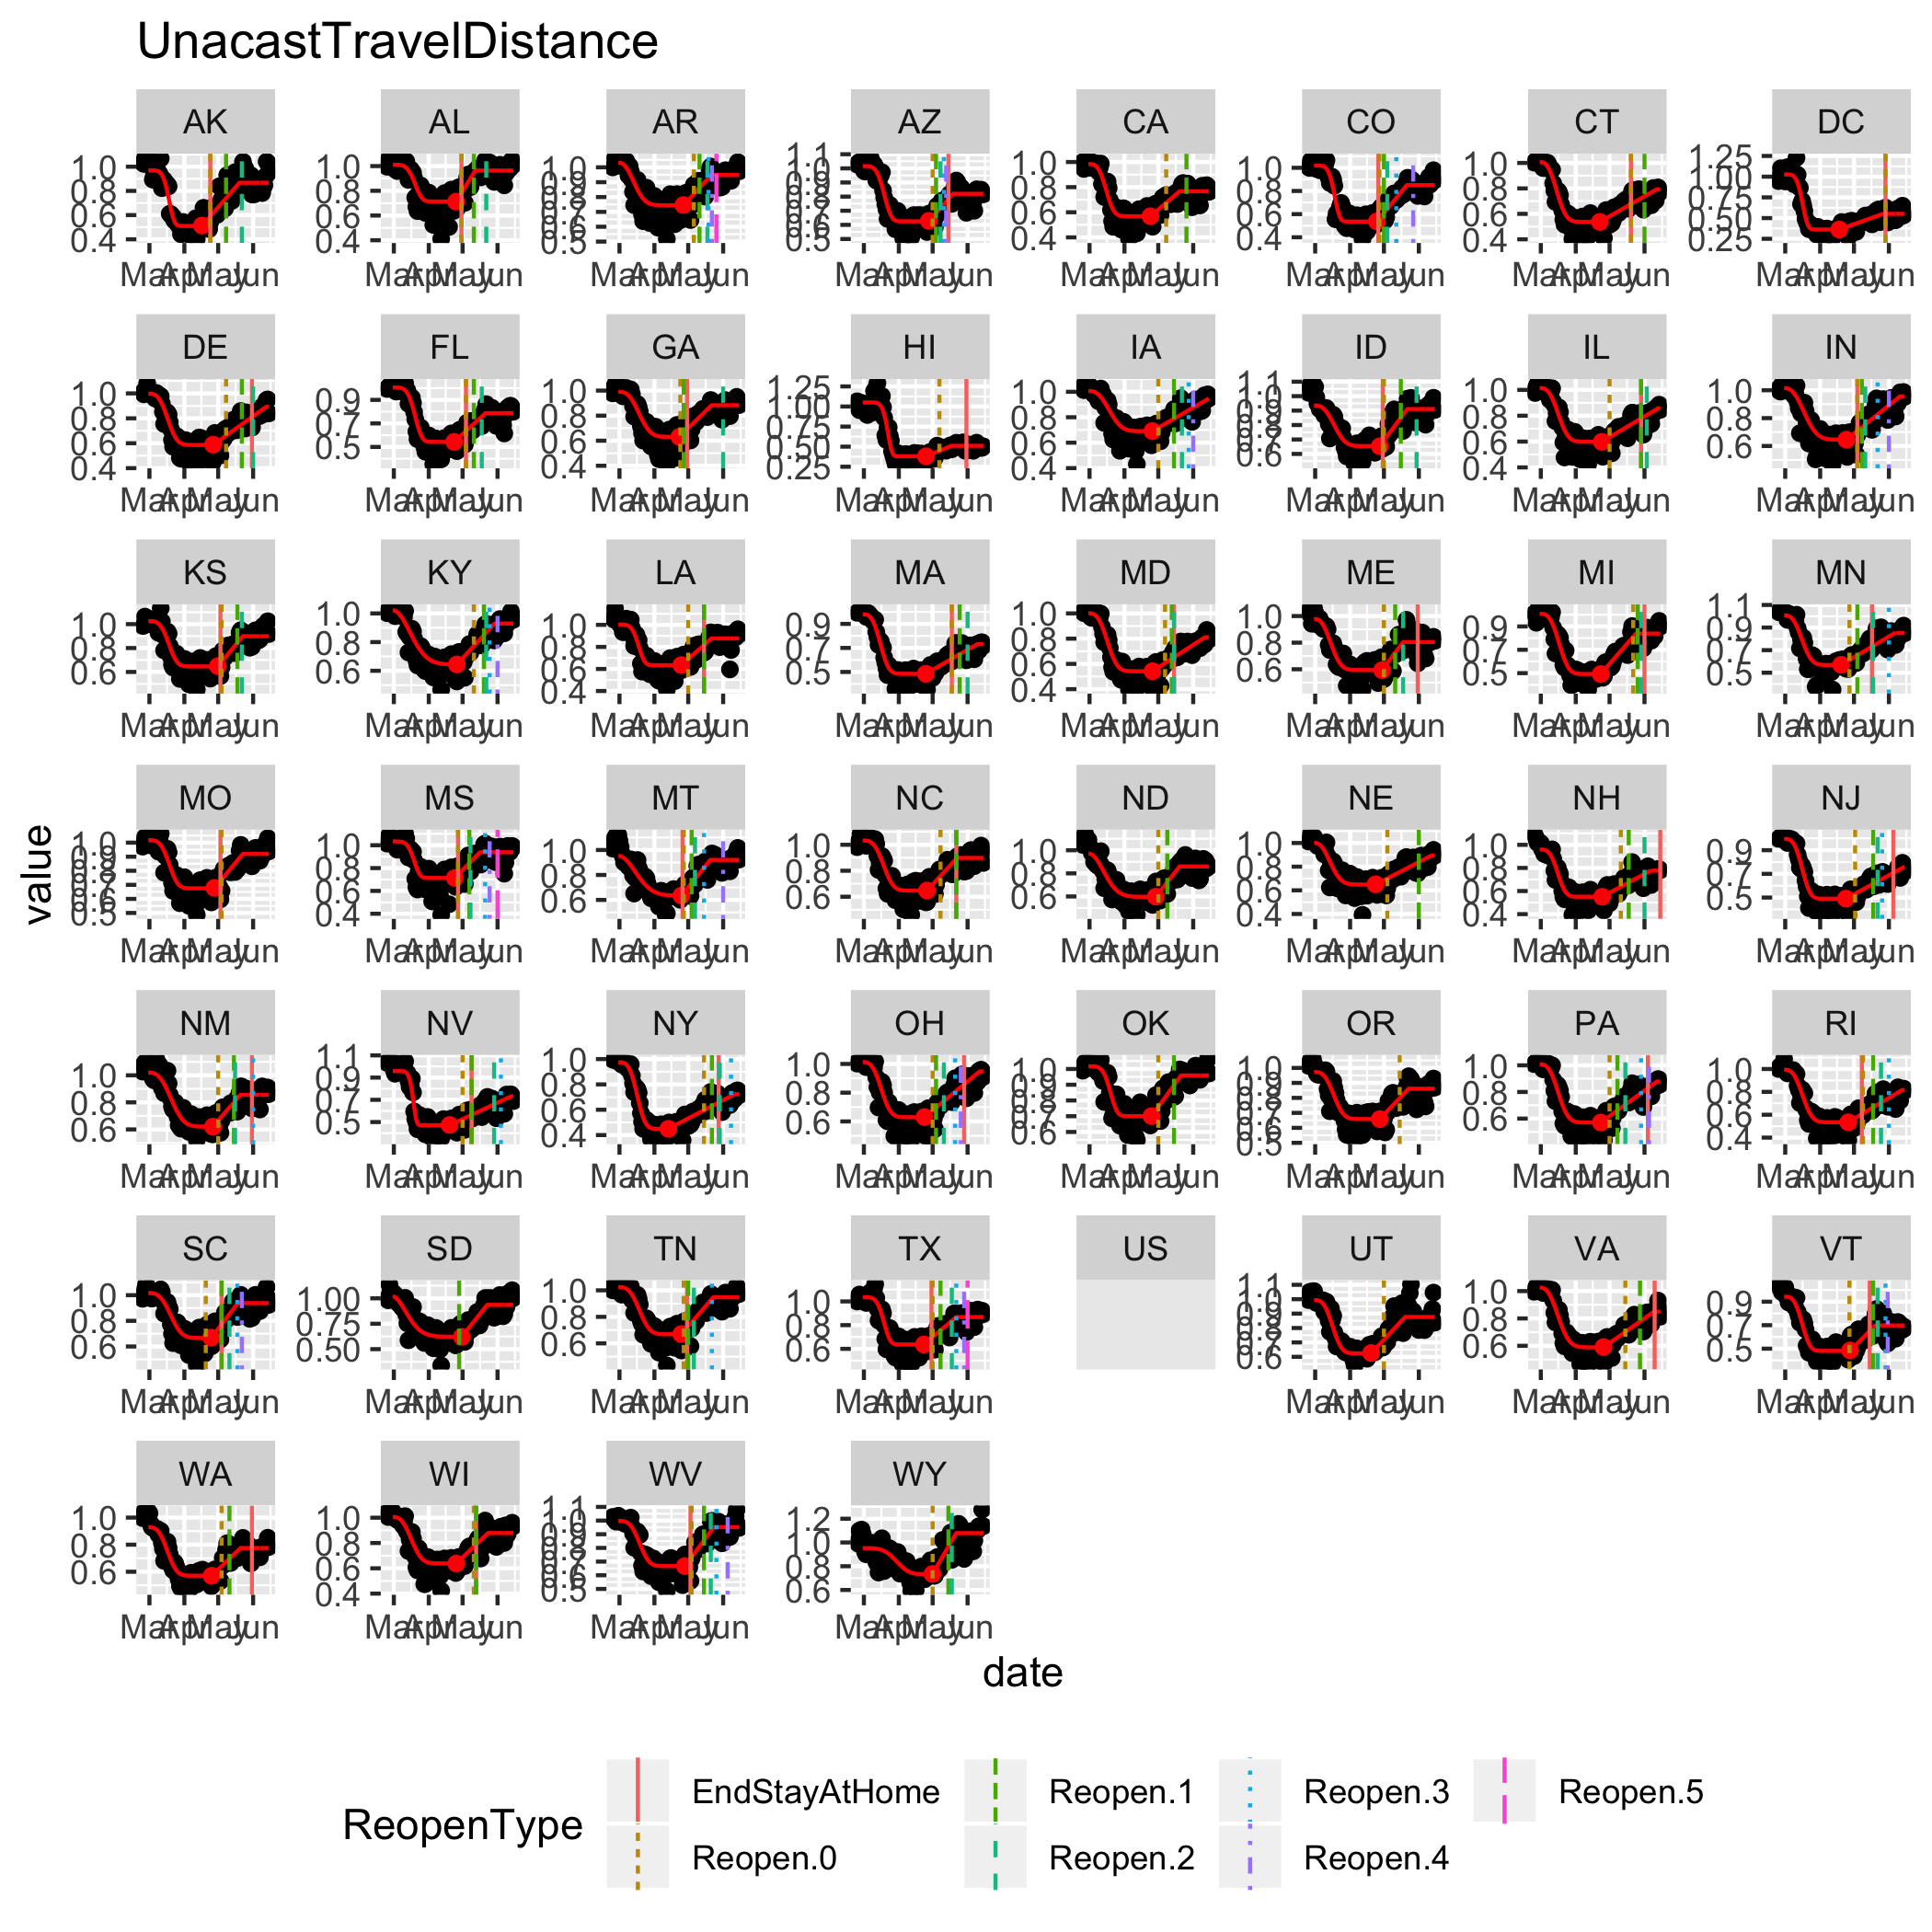

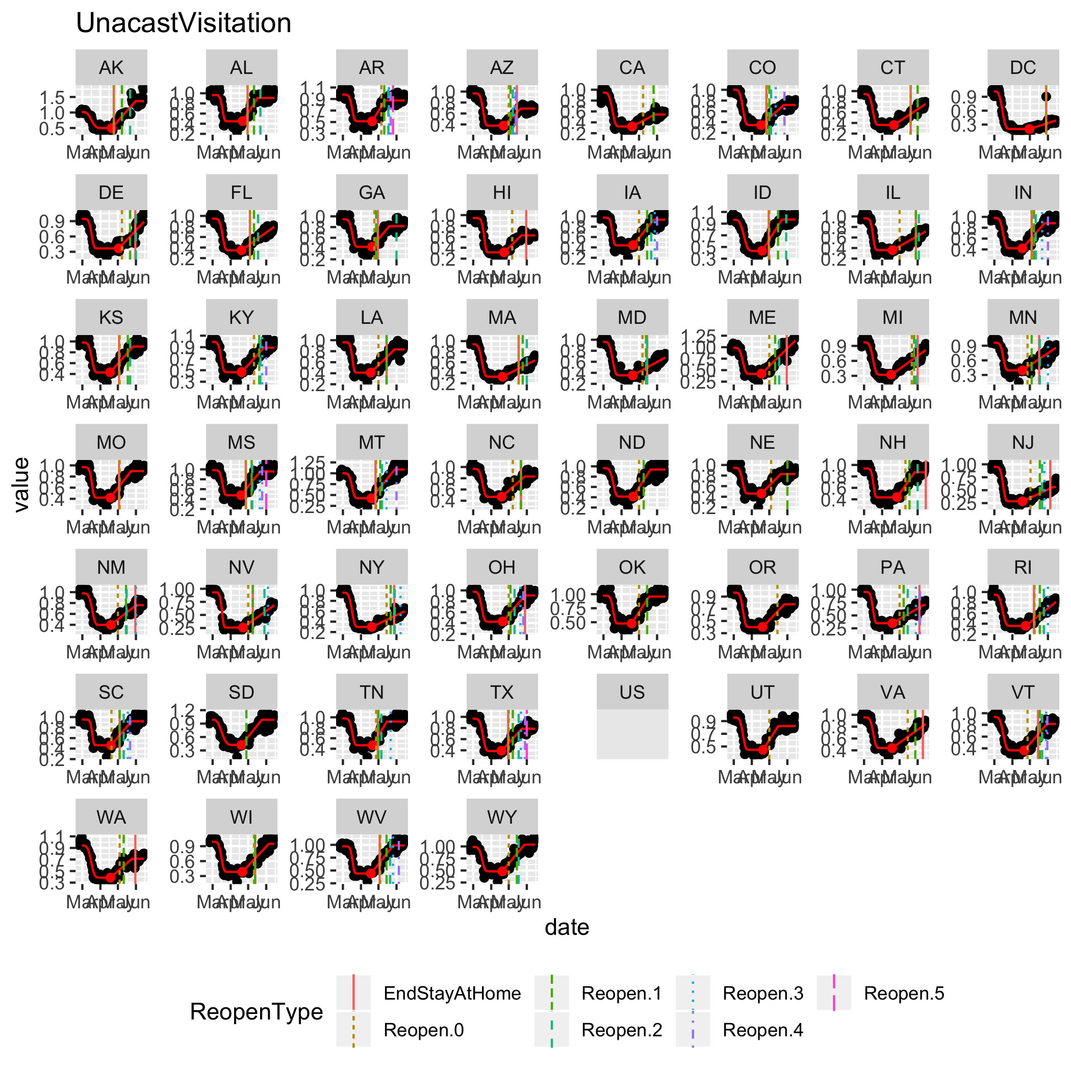

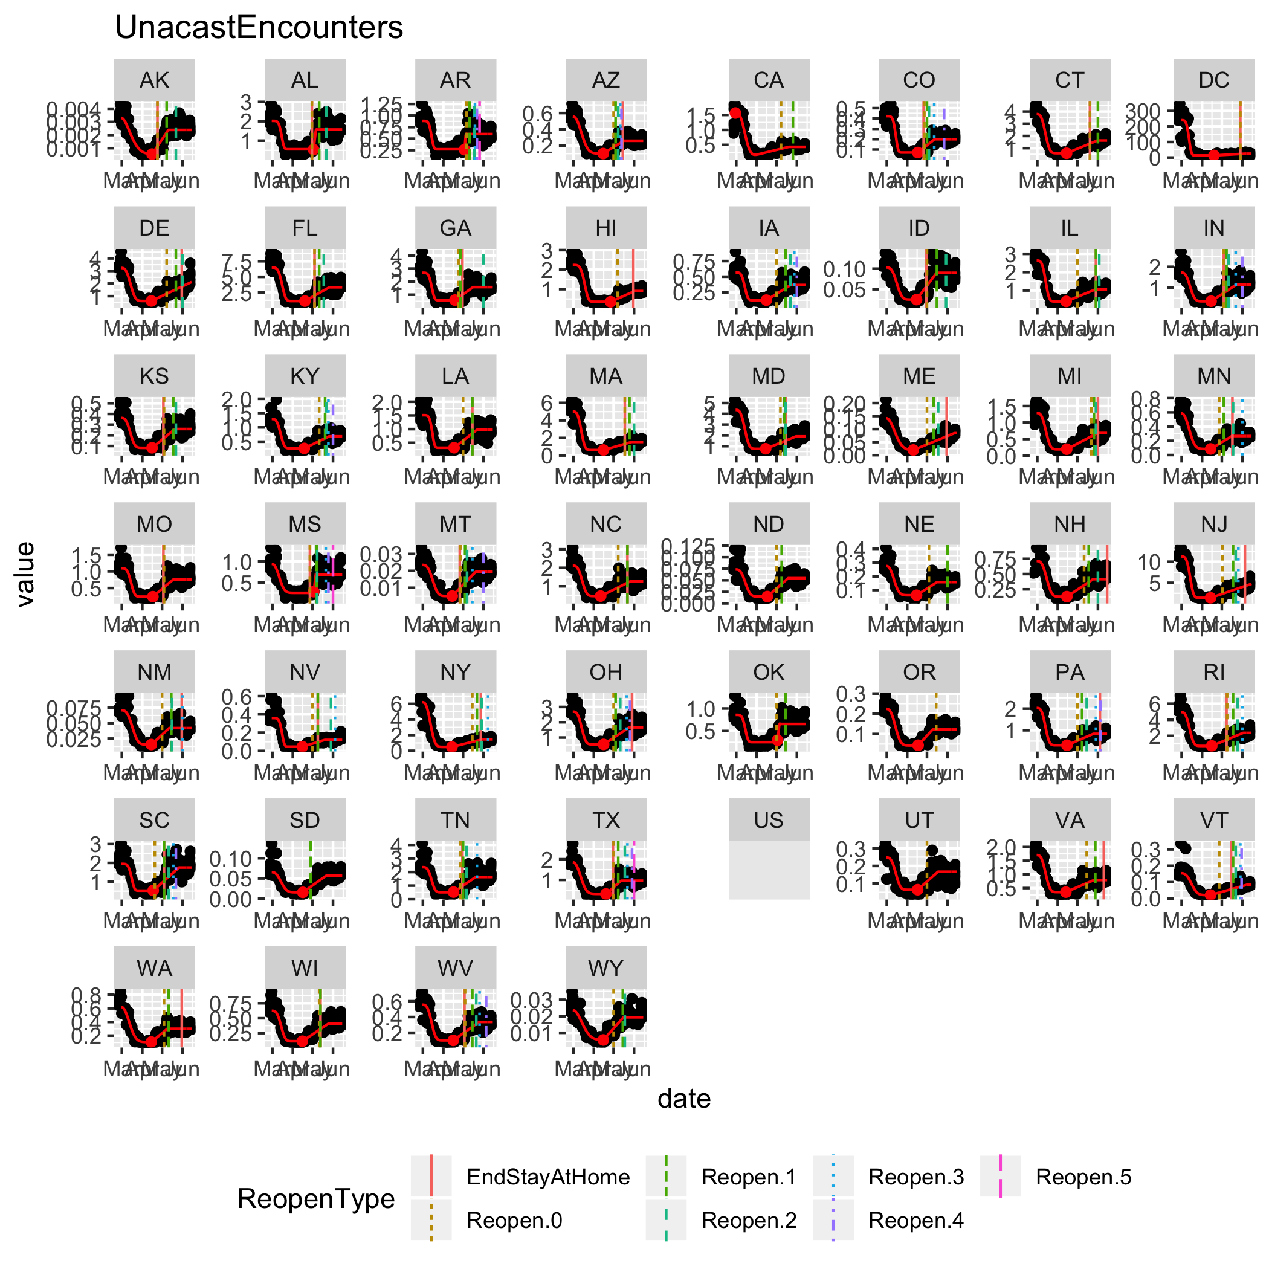

### Google

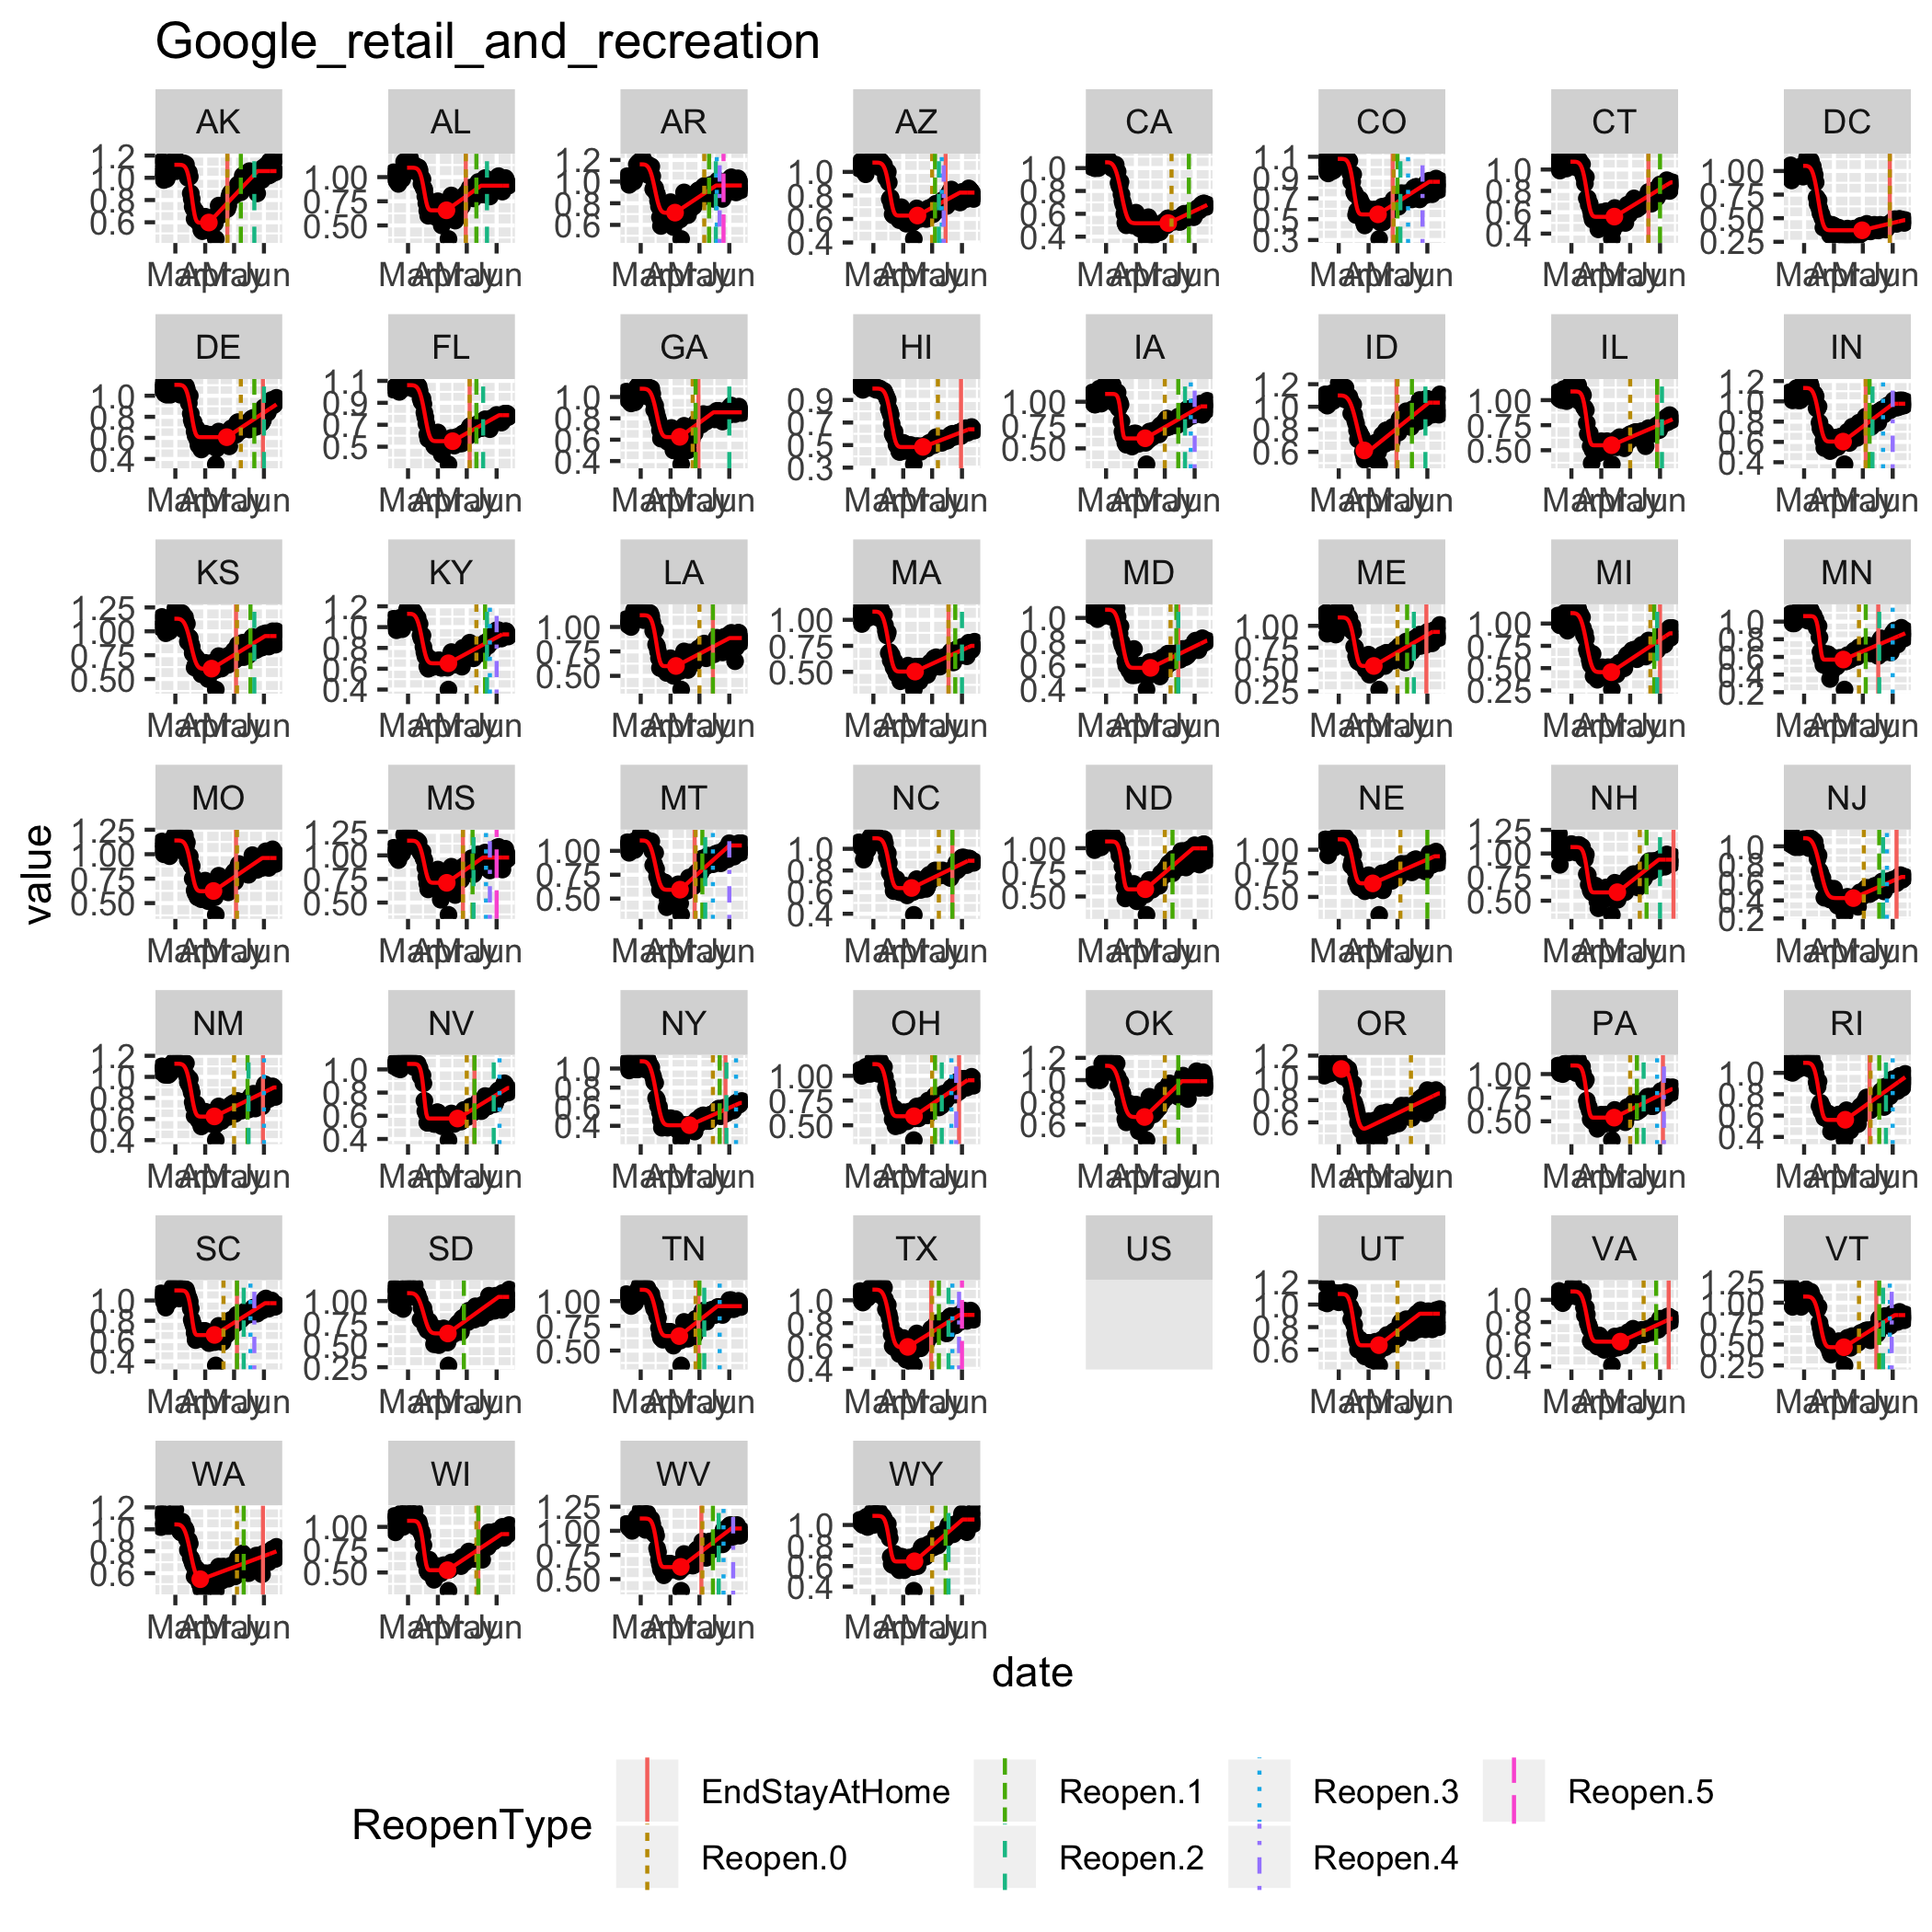

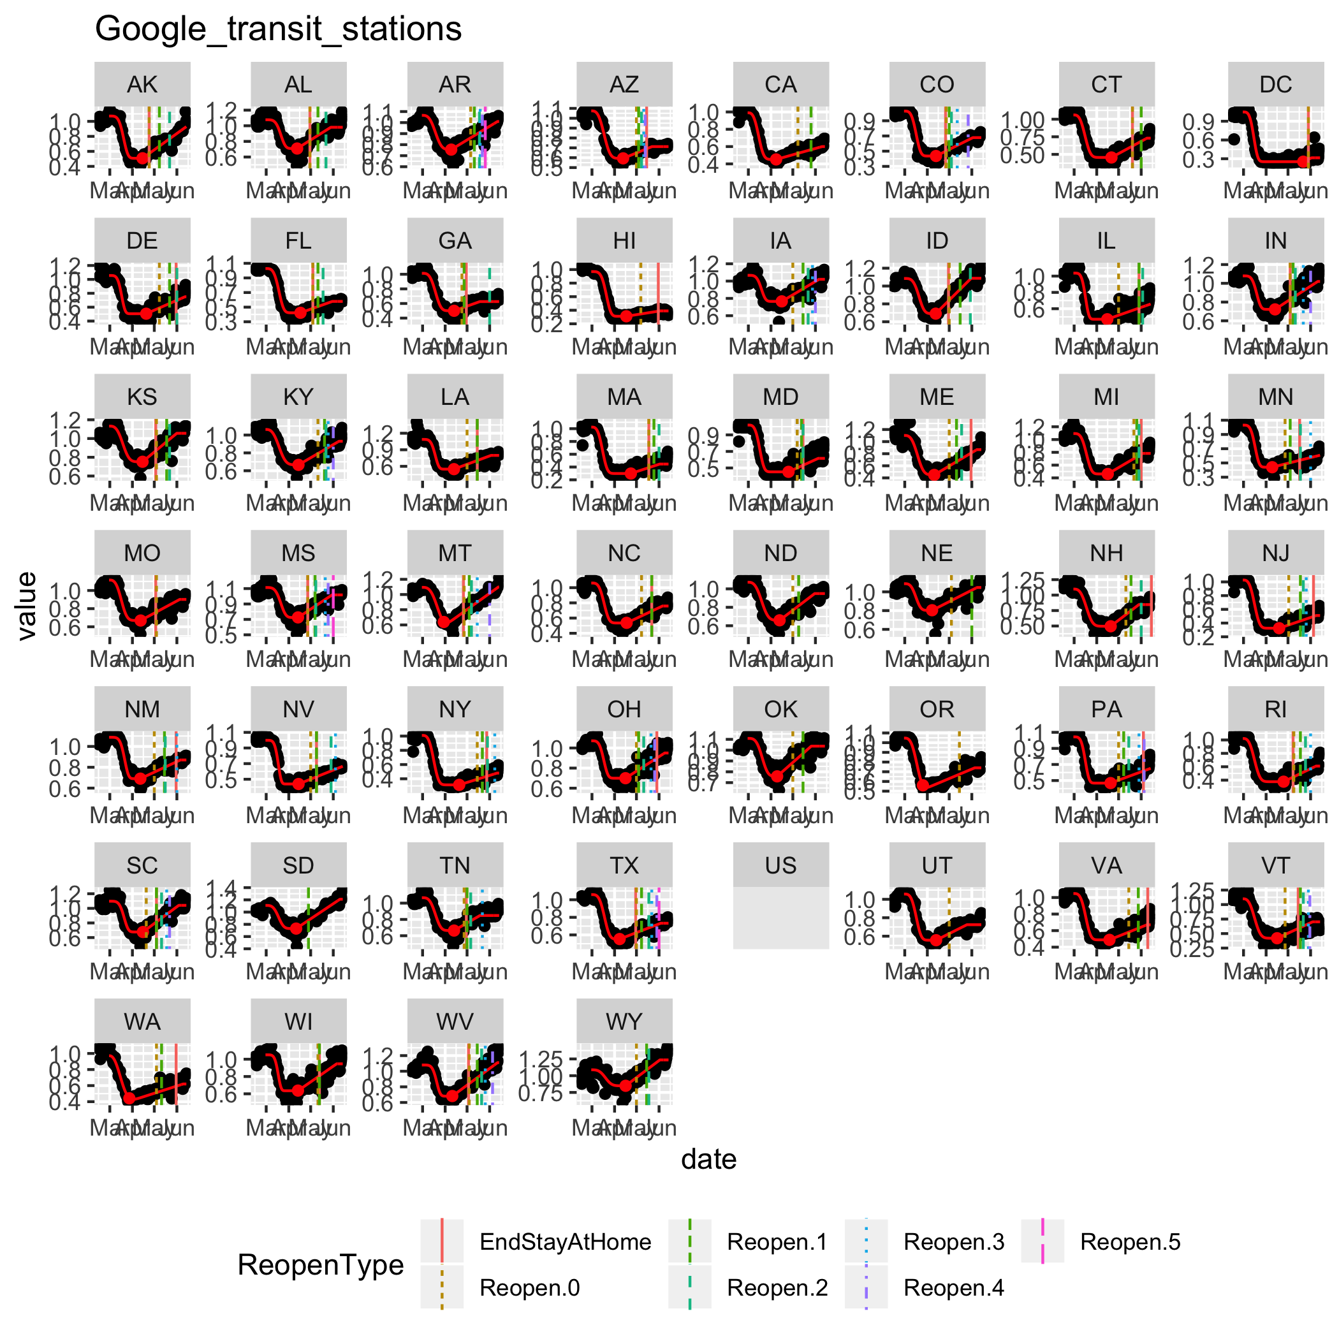

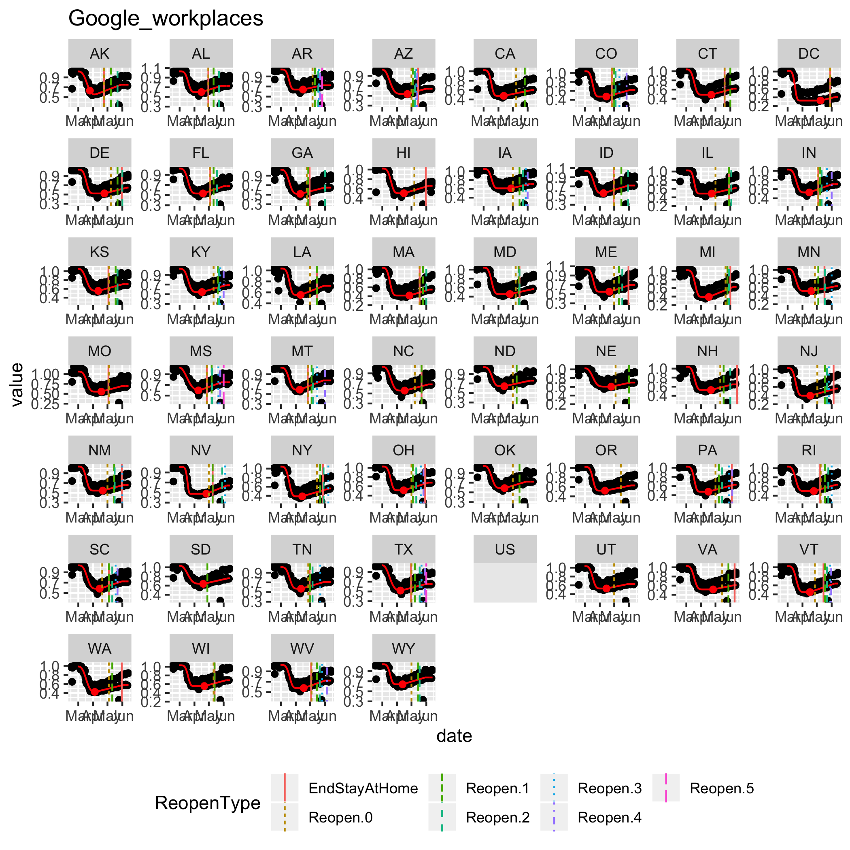

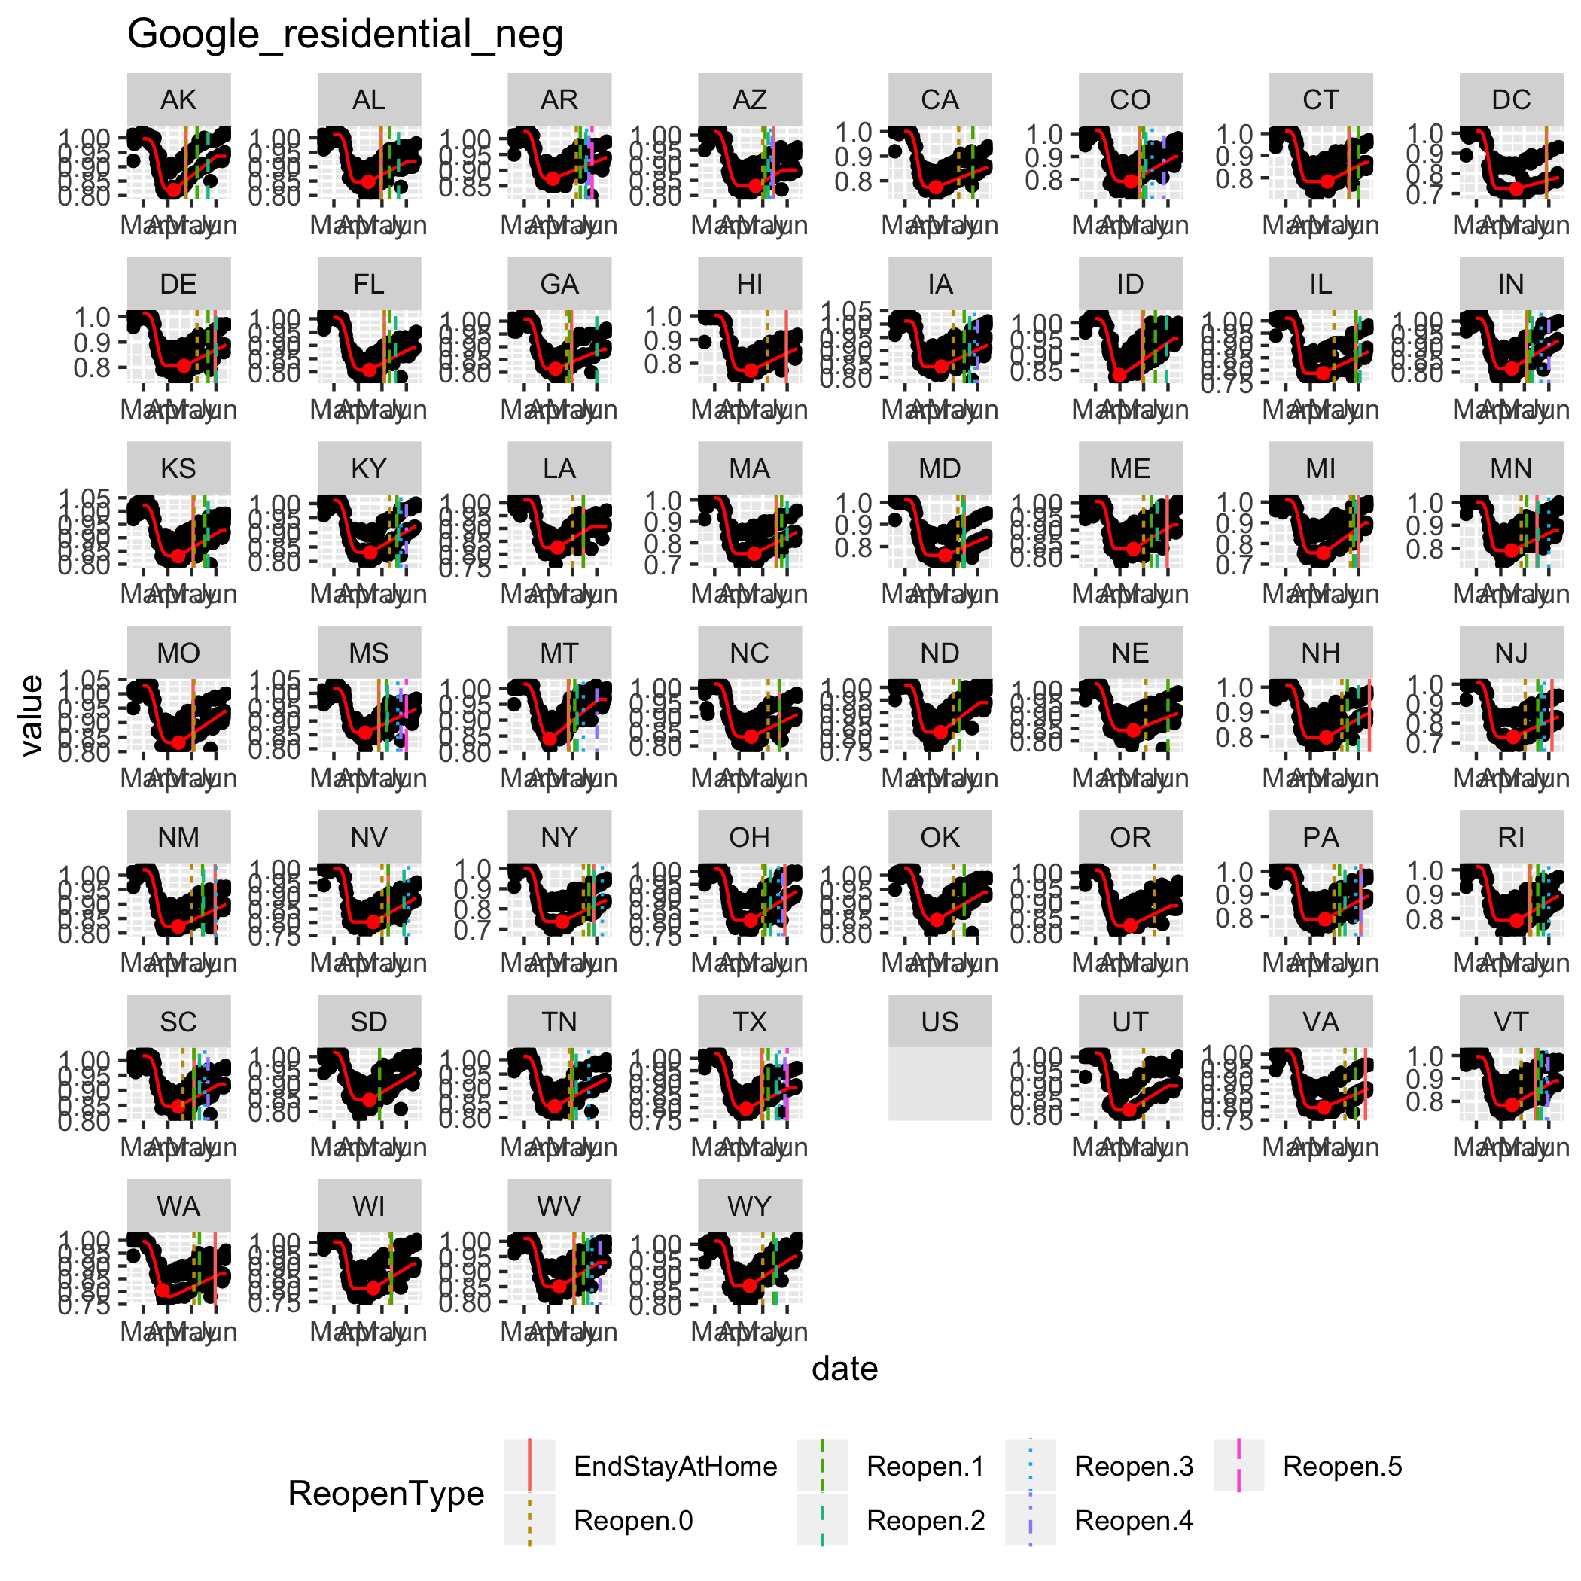

### OpenTable

If missing, substitute US country-wide value.

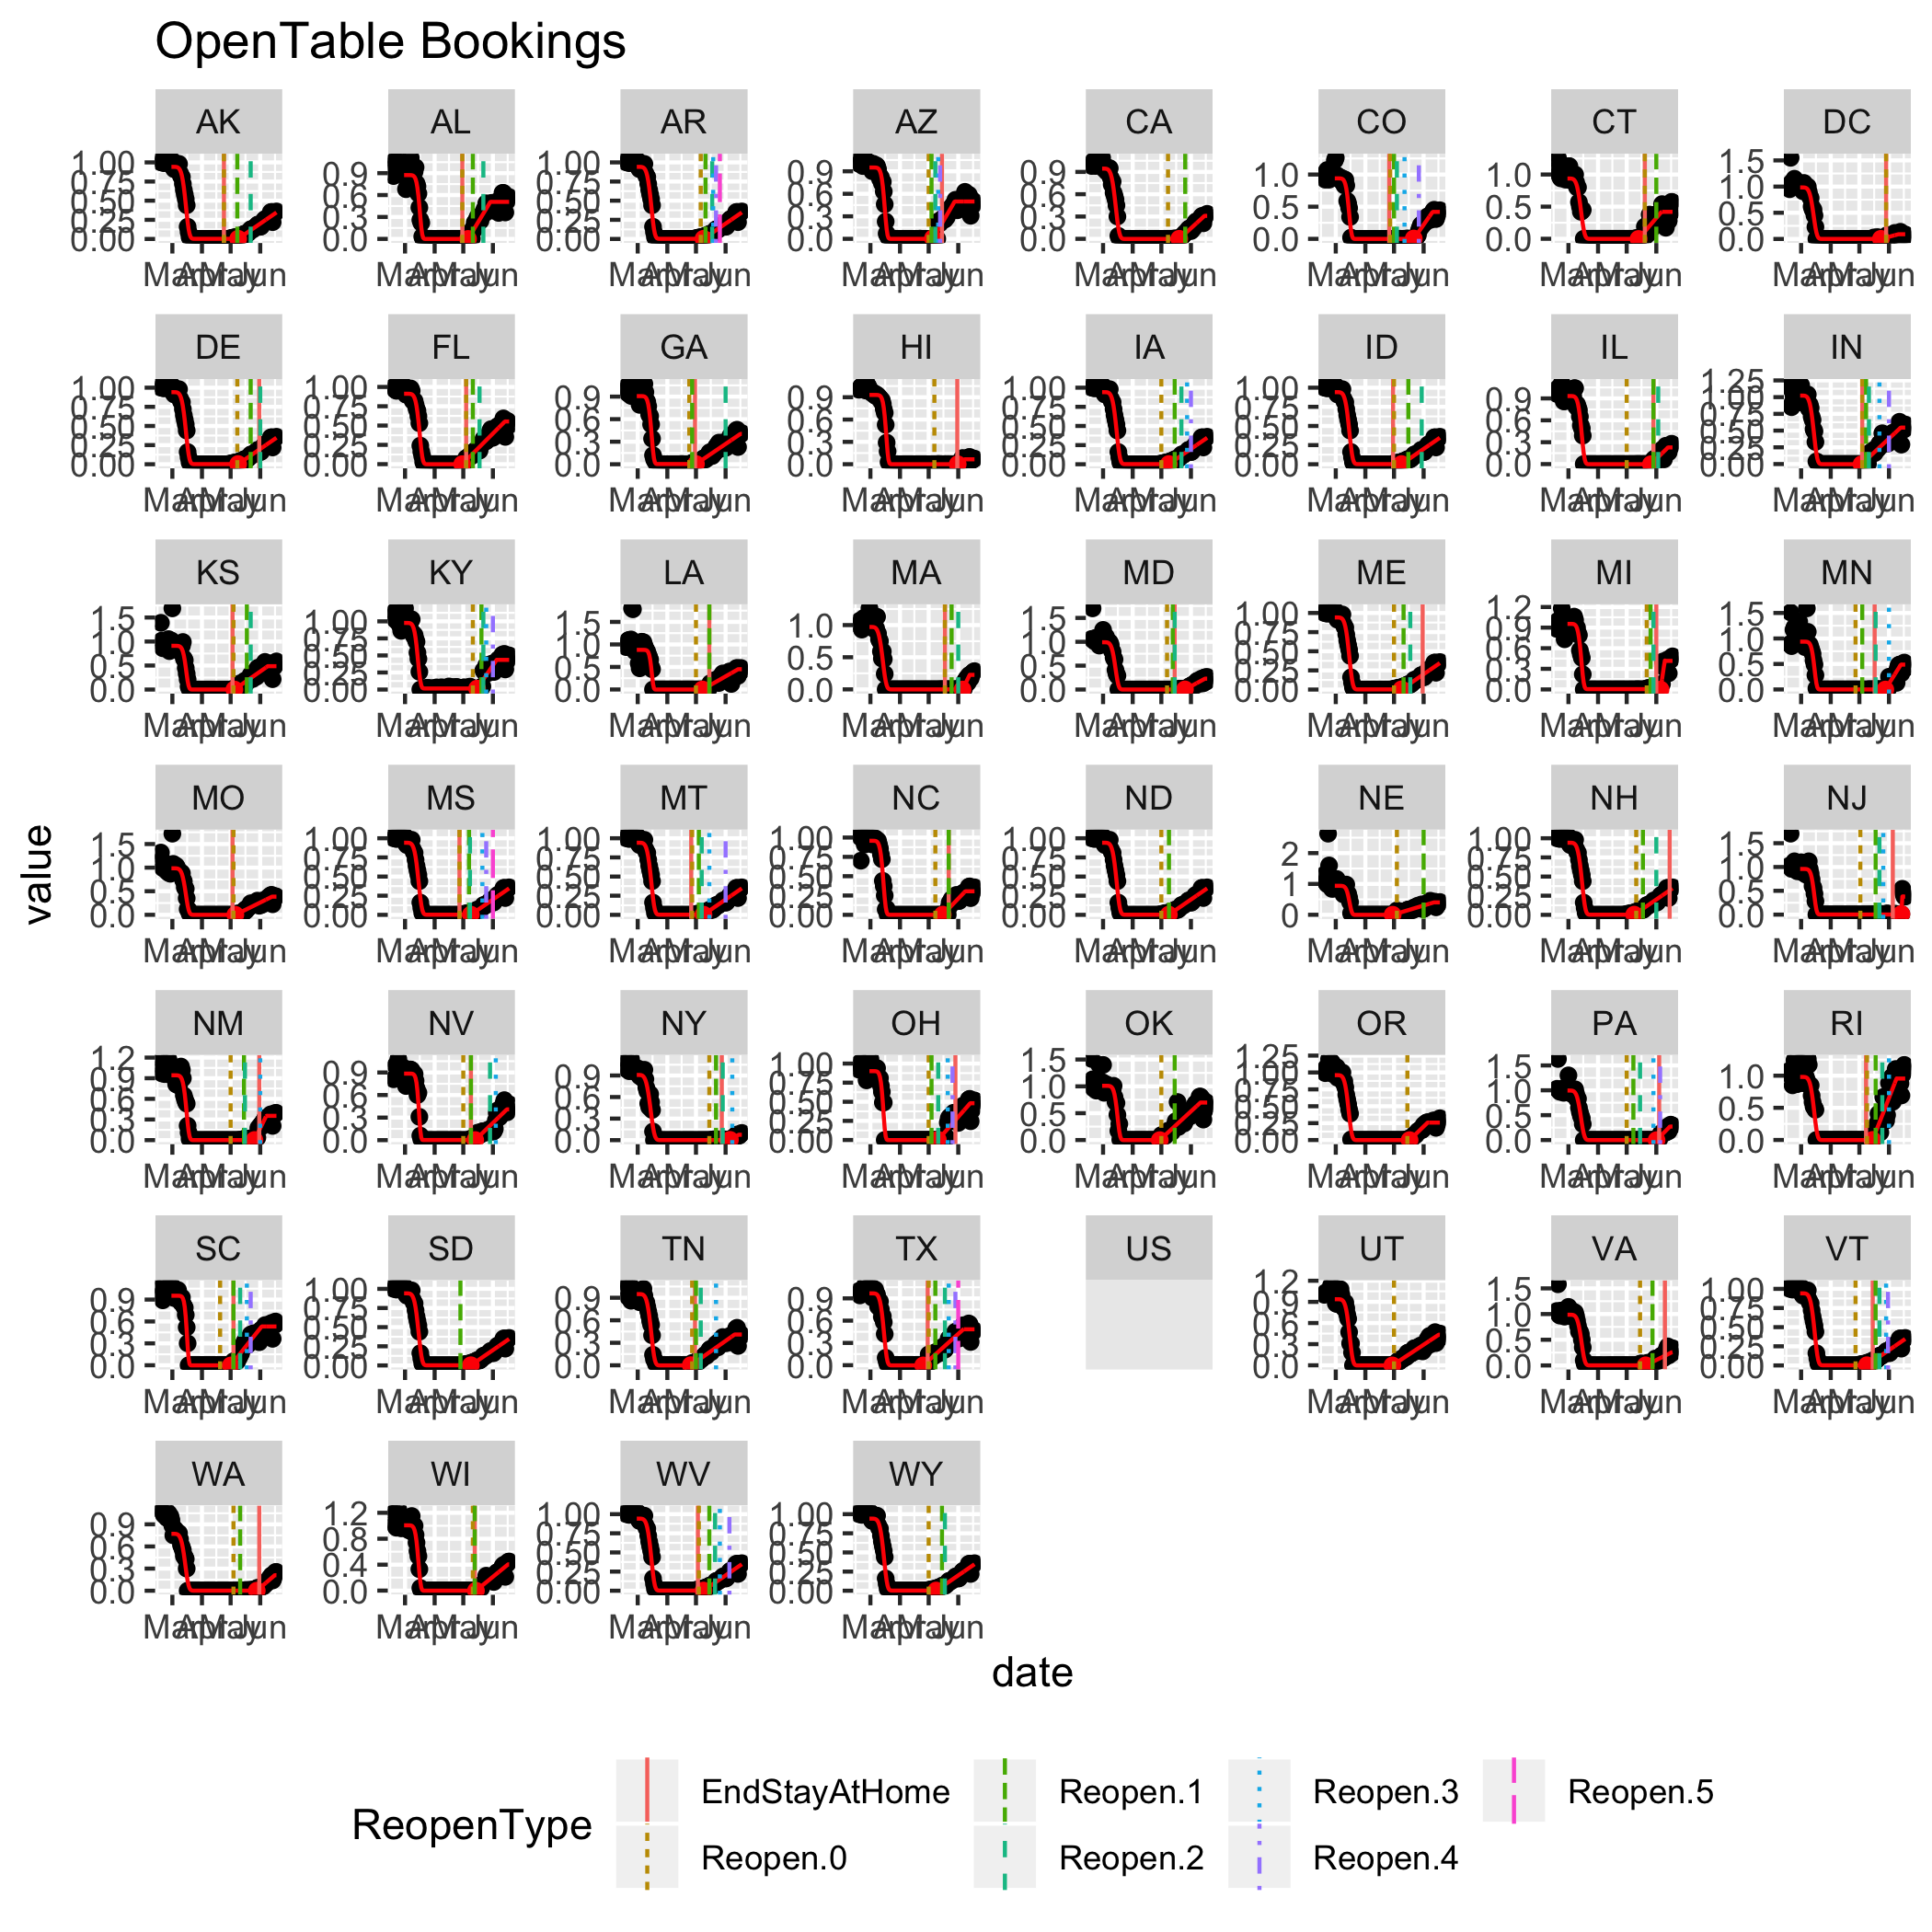

## Discussion

The Weibull+linear parameterization gives an adequate fit to the time-dependence for all the mobility data sources investigated.

Of note is that for all mobility data sources except for restaurant reservations, the linear increase began *prior* to the first re-opening milestone. Therefore, it is not necessarily reliable to rely upon announced re-opening dates to represent when changes in transmission rates may occur.